Day 5 classwork:

35.Write a program to recursively calculate the GCD (Greatest Common Divisor) of two numbers.

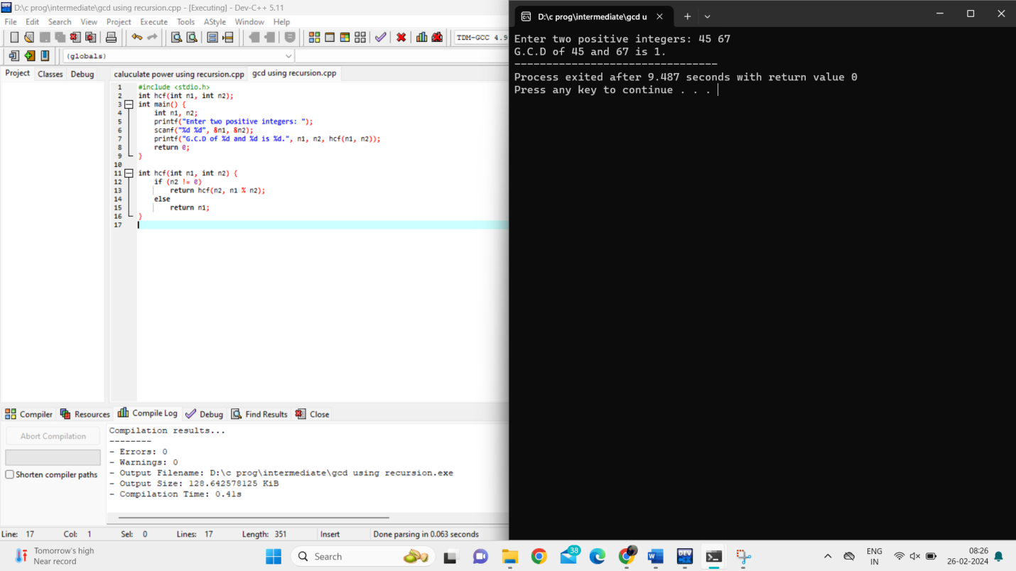

36.Implement a recursive program to find the sum of elements in an array.

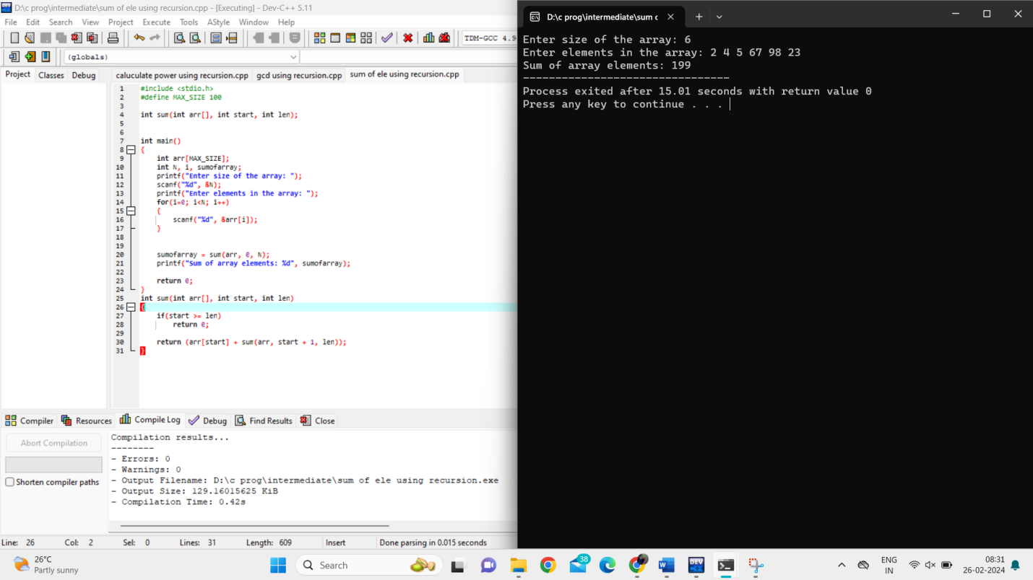

37.Write a program to recursively check if a given string is a palindrome.

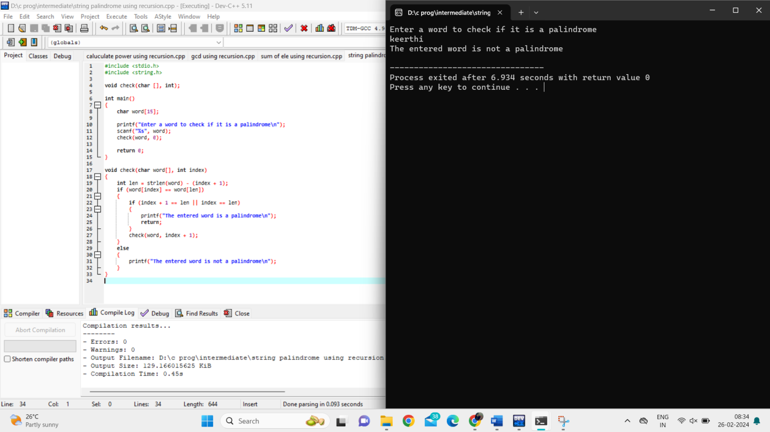

38.Implement a recursive program to reverse a string.

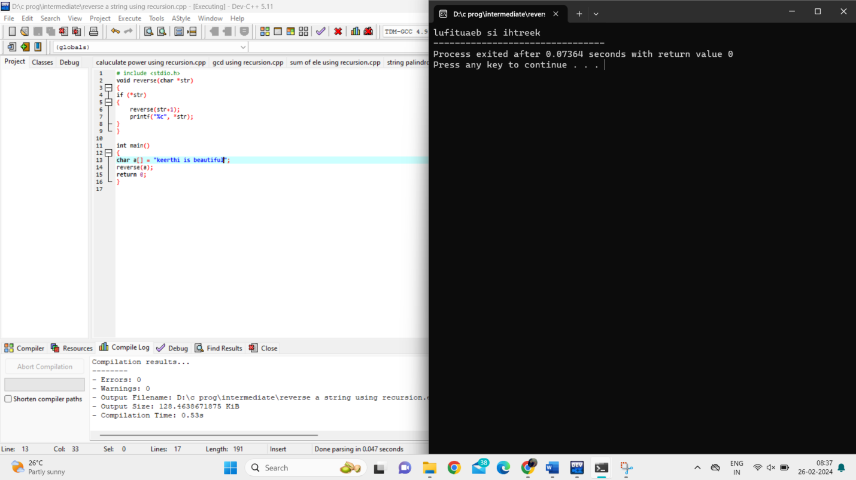

39.Write a program to recursively solve the Tower of Hanoi problem for n disks.

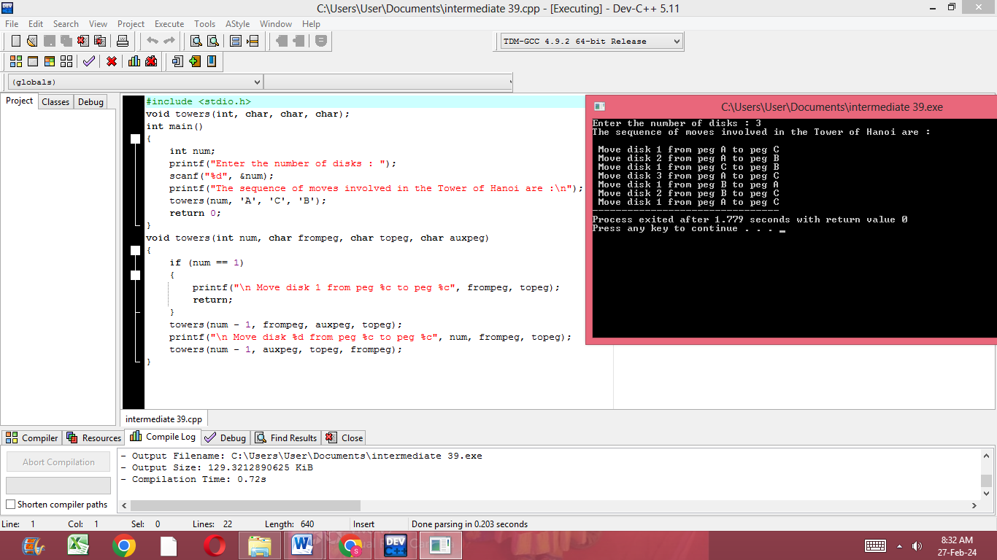

40.Implement a recursive program to generate all possible permutations of a given string.

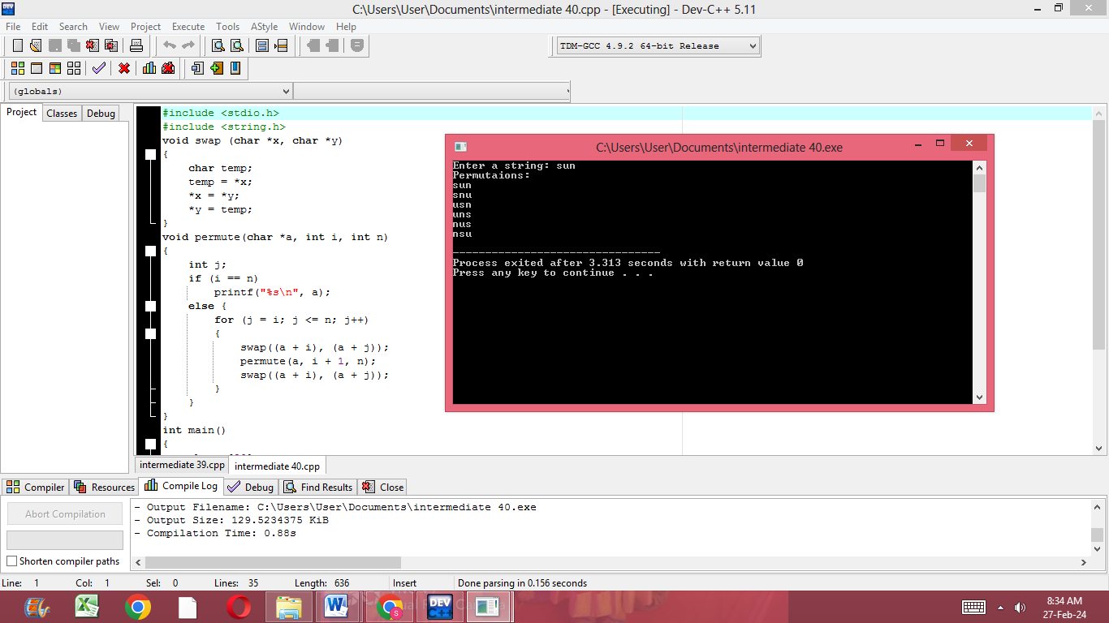

41.Write a program to recursively calculate the sum of all even numbers in a given range.

